## 水平線

**Efficient Conveyor Belt System for Preparing Dataset in Machine Learning**

2018/ 06 / 01

**─**

# **I. Introduction**

As what we already know, Machine Learning depends heavily on data. It’s the most crucial aspect that makes algorithm training possible. But regardless of your actual terabytes of information and data science expertise, if you can’t make sense of data records, a machine will be nearly useless or perhaps even harmful. The thing is, all datasets are flawed. That’s why data preparation is such an important step in the machine learning process. In a nutshell, data preparation is a set of procedures that helps make your dataset more suitable for machine learning. In the specific term of taking photos for image classification projects using Deep Learning, the dataprep also includes establishing the right data collection mechanism. And, these procedures consume most of the time spent on machine learning. Sometimes it takes months before the first algorithm is built.

To solve these problems mentioned above, Conveyor Belt project aims making the dataprep becomes more automatic and efficient, as well as cost savings of manual collecting data.

This short paper will describe about how we make a simple prototype of Conveyor Belt System to taking photos of object using DSLR camera.

# **II. Overall System**

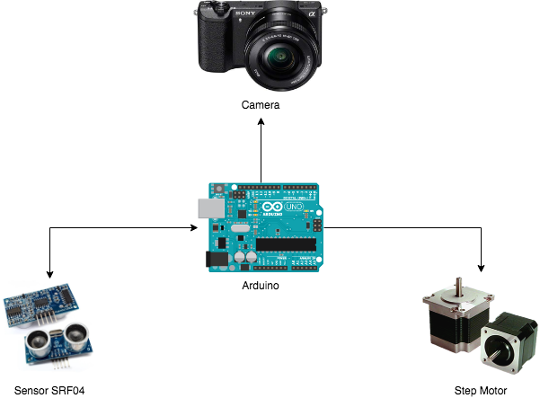

Figure 1. The Overall System

## II.1. Connecting of Step Motor and Arduino

### II.1.1. Step Motor and Arduino UNO Connection

Required components:

* Sensor HC-SR04
* Arduino Uno R3 Board
* Breadboard and Jump Wires

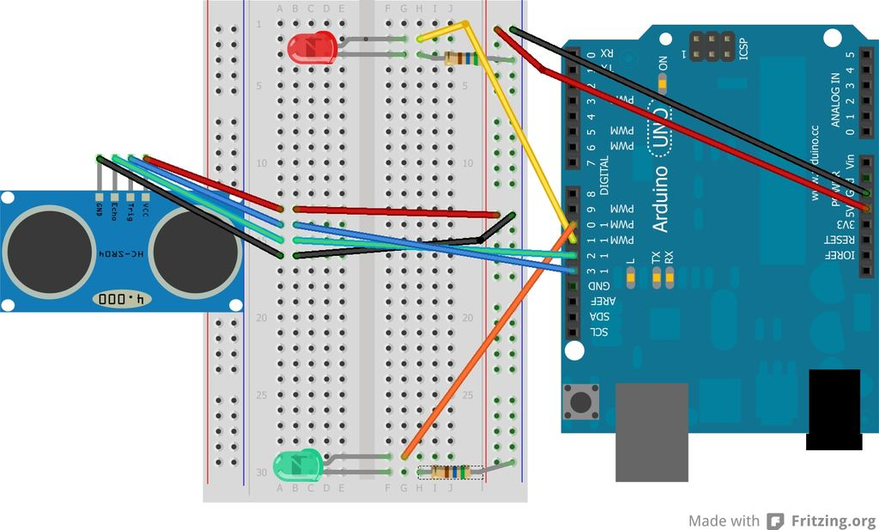

Figure 2. SRF04 and Arduino UNO Connection

### II.1.2. How it works

The HC-SRF04 Module has 4 pins, Ground, VCC, Trig and Echo. The Ground and the VCC pins of the module needs to be connected to the Ground and the 5 volts pins on the Arduino Board respectively and the trig and echo pins to any Digital I/O pin on the Arduino Board.

In order to generate the ultrasound we need to set the Trig on a High State for 10 µs. That will send out an 8 cycle sonic burst which will travel at the speed sound and it will be received in the Echo pin. The Echo pin will output the time in microseconds the sound wave traveled.

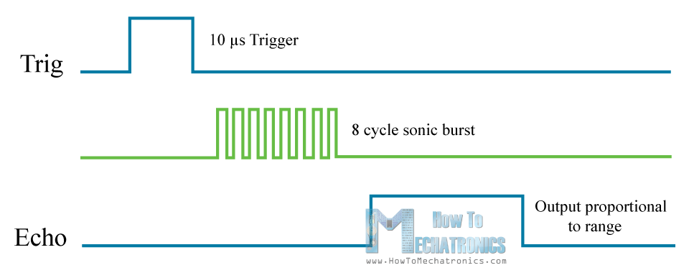

Figure 3. Send a pulse with duration of 10uS from Trig PIN

So, when setting up this sensor on the Conveyor Belt, we need to compute the width of conveyor, called **⍺**, then if the distance of detected object and the sensor is less than **⍺**, it means that is the right time to active the camera for taking photos.

### II.1.3. Source code

The getDistance between object to sensor.

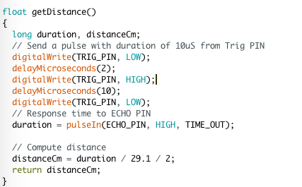

## II.2. Connecting of sensor SRF04 and Arduino

### II.2.1. SRF04 and Arduino UNO Connection

Required components:

* Step Motor Nema 17
* A4988 Stepper Driver
* 12V 2A Adapter
* Arduino Uno R3 Board

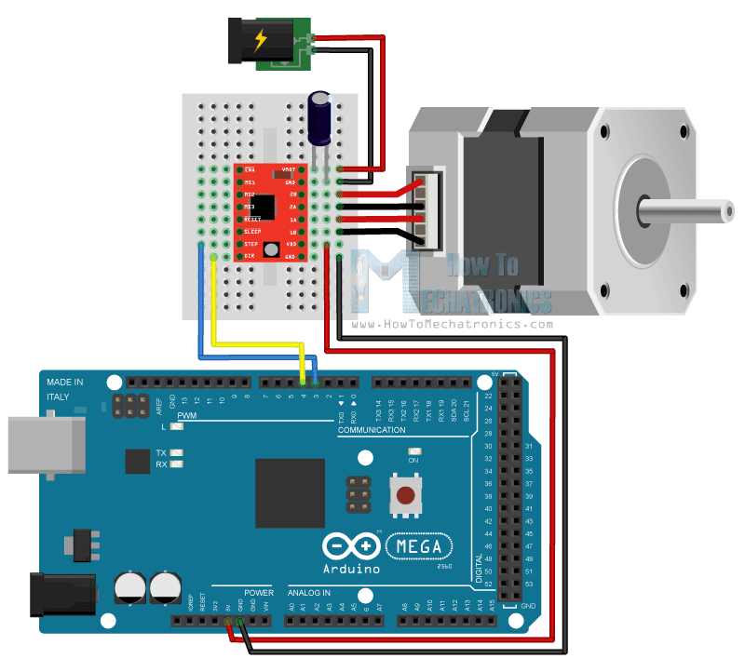

Figure 4. Step Motor and Arduino UNO Connection

### II.2.2. How it works

To control step motor with Arduino, we need to use the drive in Full Step Mode. It means we need to send 200 pulses into the Step Pin to make one full cycle rotation, so we will leave the 3 pins disconnected and just connect the Direction and the Step pins of the drive to the pins number 3 and 4 on the Arduino Board and as well the Ground and the 5V pins for powering the board. Also we will use a 100µF capacitor for decoupling and 12V, 1.5A adapter for powering the motor. We will use a NEMA 17 bipolar Stepper Motor and its wires A and C will be connected to the pins 1A and 1B and the B and D wires to the 2A and 2B pins.

One thing need to be considered that is we need to stop the step motor immediately when the object coming. If we use full circle rotation mode, the motor is still turn a little bit to finish its rotation. Therefore, we will reduce the cycle rotation as much as it can. In this case, step motor NEMA 17 can perform 1/16 of a full cycle rotation.

### II.2.3. Source code

The function of control step motor.

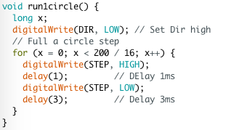

## II.3. Connecting of DSLR Camera and Arduino

### II.3.1. Camera and Arduino UNO Connection

Required components:

* Sony a6000
* Multi-connection cable
* Opto PC817
* Arduino Uno R3 Board

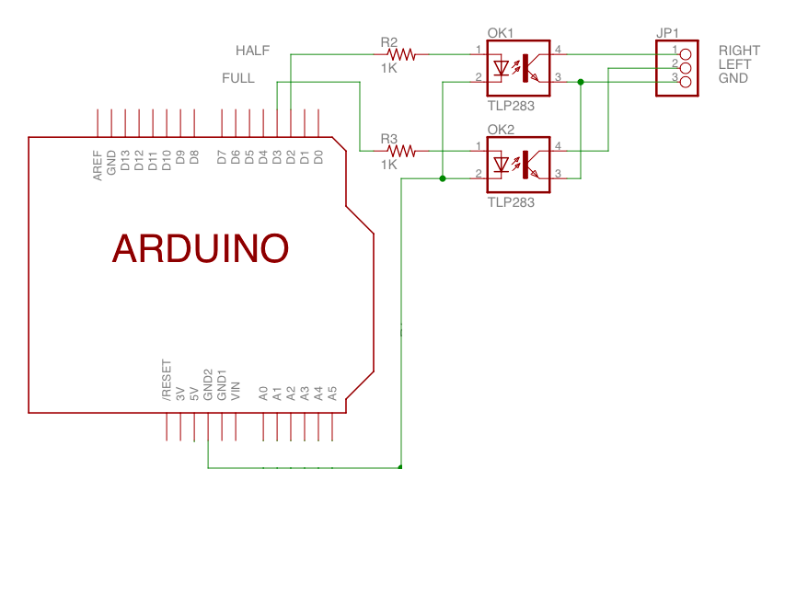

Figure 5. Sony a6000 and Arduino UNO Connection

### II.3.2. How it works

When the RIGHT, LEFT and GND pins is connected together, the shooter of camera will be activated. We use 2 optos PC817 as triggers to join these ins into as one. Specifically, the first 1kΩ resistor is connected between pin 2 on the arduino board and the positive side of the optocouplers led in the chip, this resistor cuts down the voltage from the board so it does not overpower the led and burn it out. Similarly, the second 1kΩ resistor is also connected to the second opto. The idea is that we set pin 2 and 3 to 5V, then the brighter inside opto will allow to pass through the phototransistor. Based on this theory, we will it to capture photos.

### II.3.3. Source code

The functions of taking photos with sony camera.

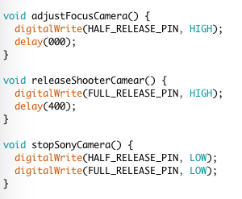

# **III. Experimental Results**

### III.1.1. Result of connecting sensor with arduino

### 

Figure 6. Connection of sensor and arduino

### III.1.1. Result of connecting step motor with arduino

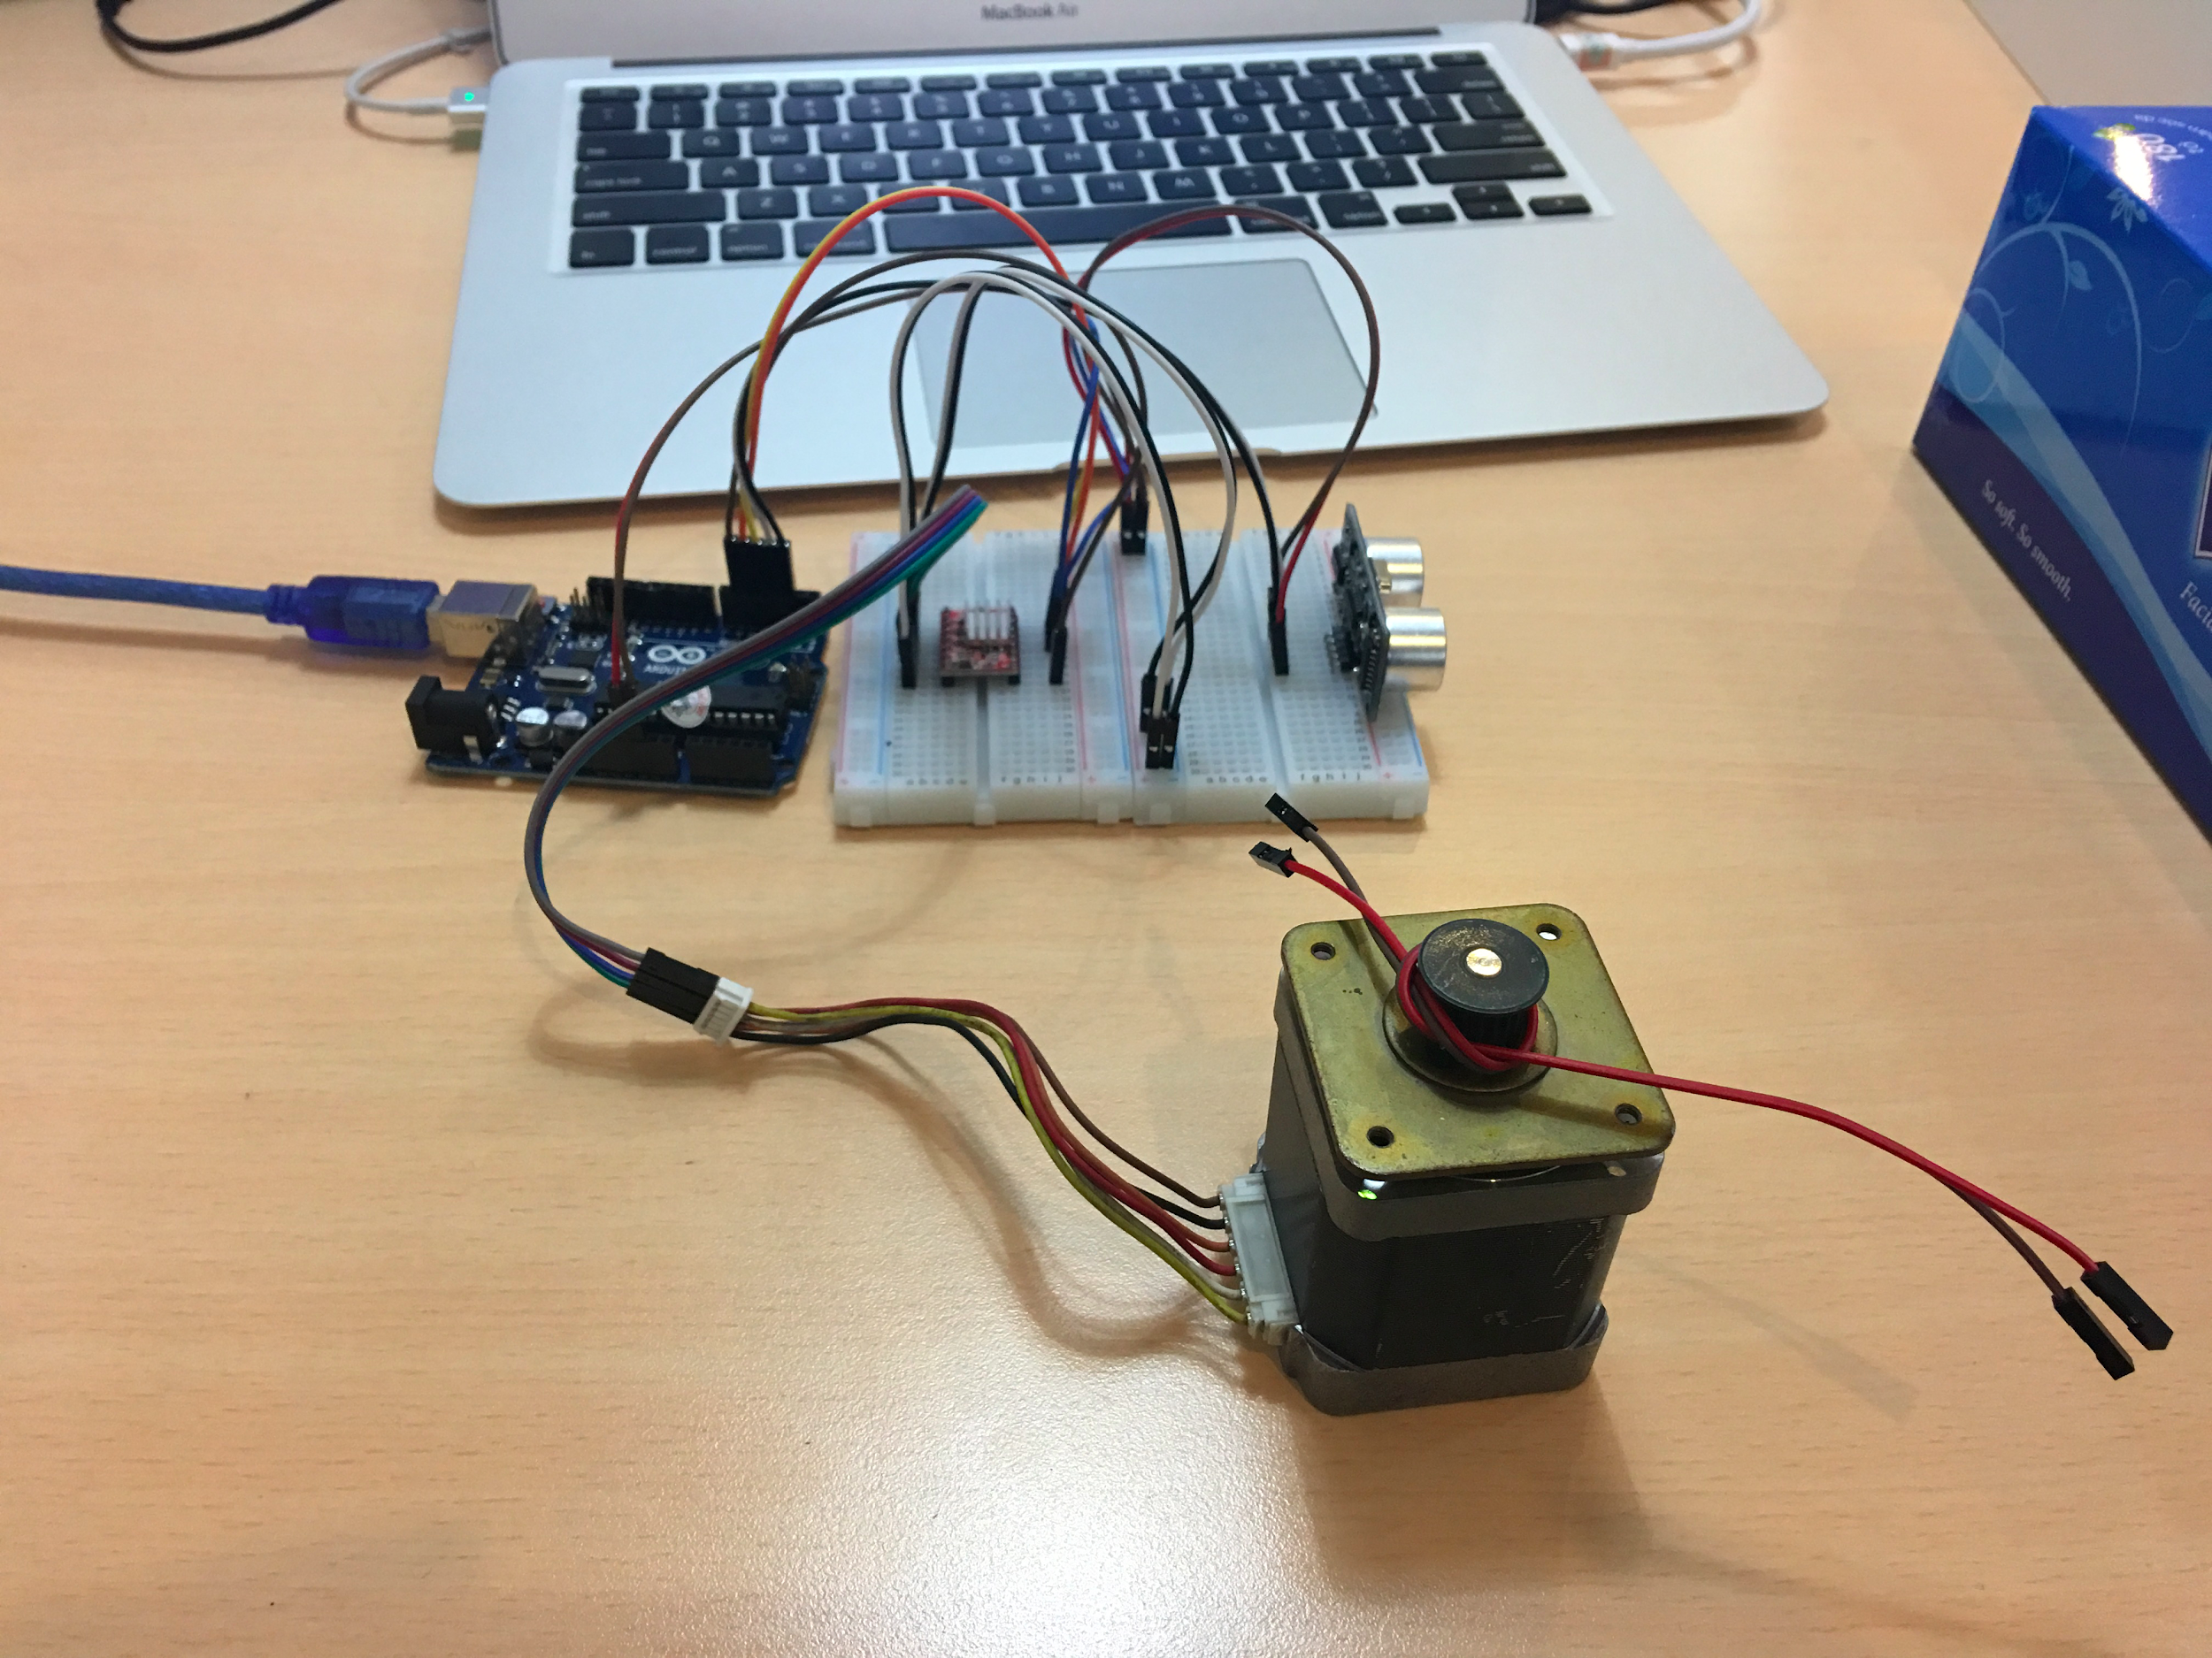

Figure 7. Connection of step motor and arduino

### III.1.1. Video demo

Please check it out in the link below.

https://goo.gl/BJWYbM

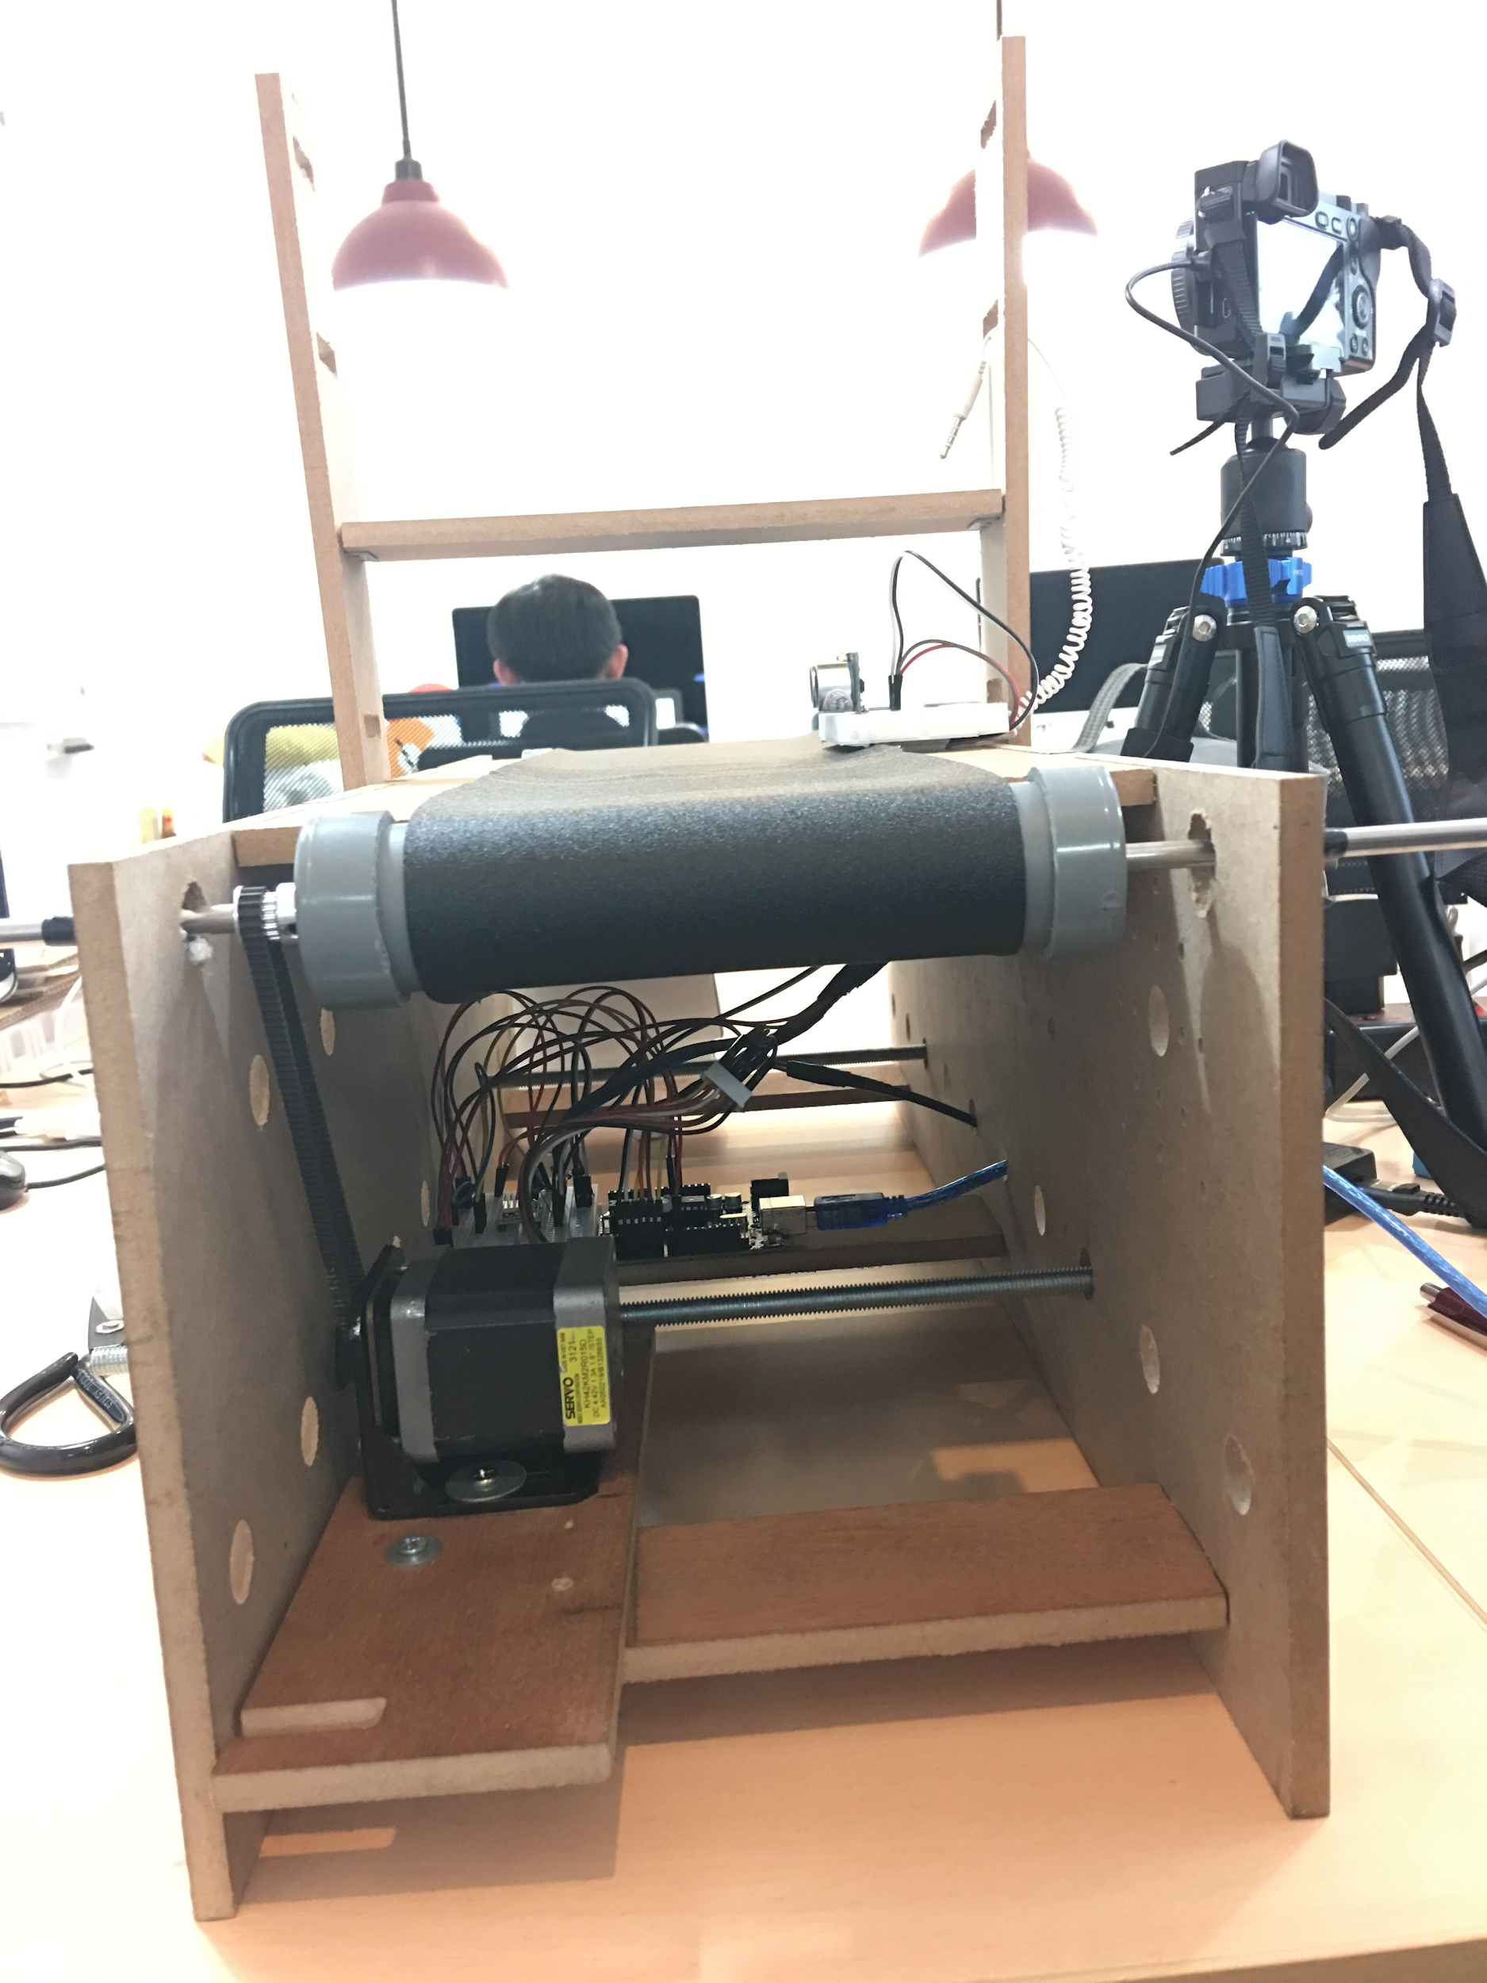

# **IV. Conclusion and improvements**

In Machine Learning, dataset is essential factor that affect to quality of models. This project aims reducing cost of manual collecting data and push the dataprep process into consistency. There are many interesting ideas based on this project we can do such as build a robot-hand to capturing object with different axis or classify object right then on the belt.

# 

# **References**

1. Images from - “<https://howtomechatronics.com>”